**University of engineering & technology Peshawar**



**Differential equation(calculus)**

**Assignment no: 2**

**Fall 2020**

**Submitted by: Ashfaq Ahmad**

**Section: B**

**Reg No: 19PWCSE1795**

**Semester: 2nd**

**“On my honor, as a student of University of Engineering and Technology Peshawar, I have neither given nor received unauthorized assistance on this academic work”**

**Student signature: ____________________**

**Submitted to:**

**Prof: qayyum shah**

**Department Of Computer System Engineering**

**Assignment no: 2**

**Exercise 4.1 (2, 4, 6)**

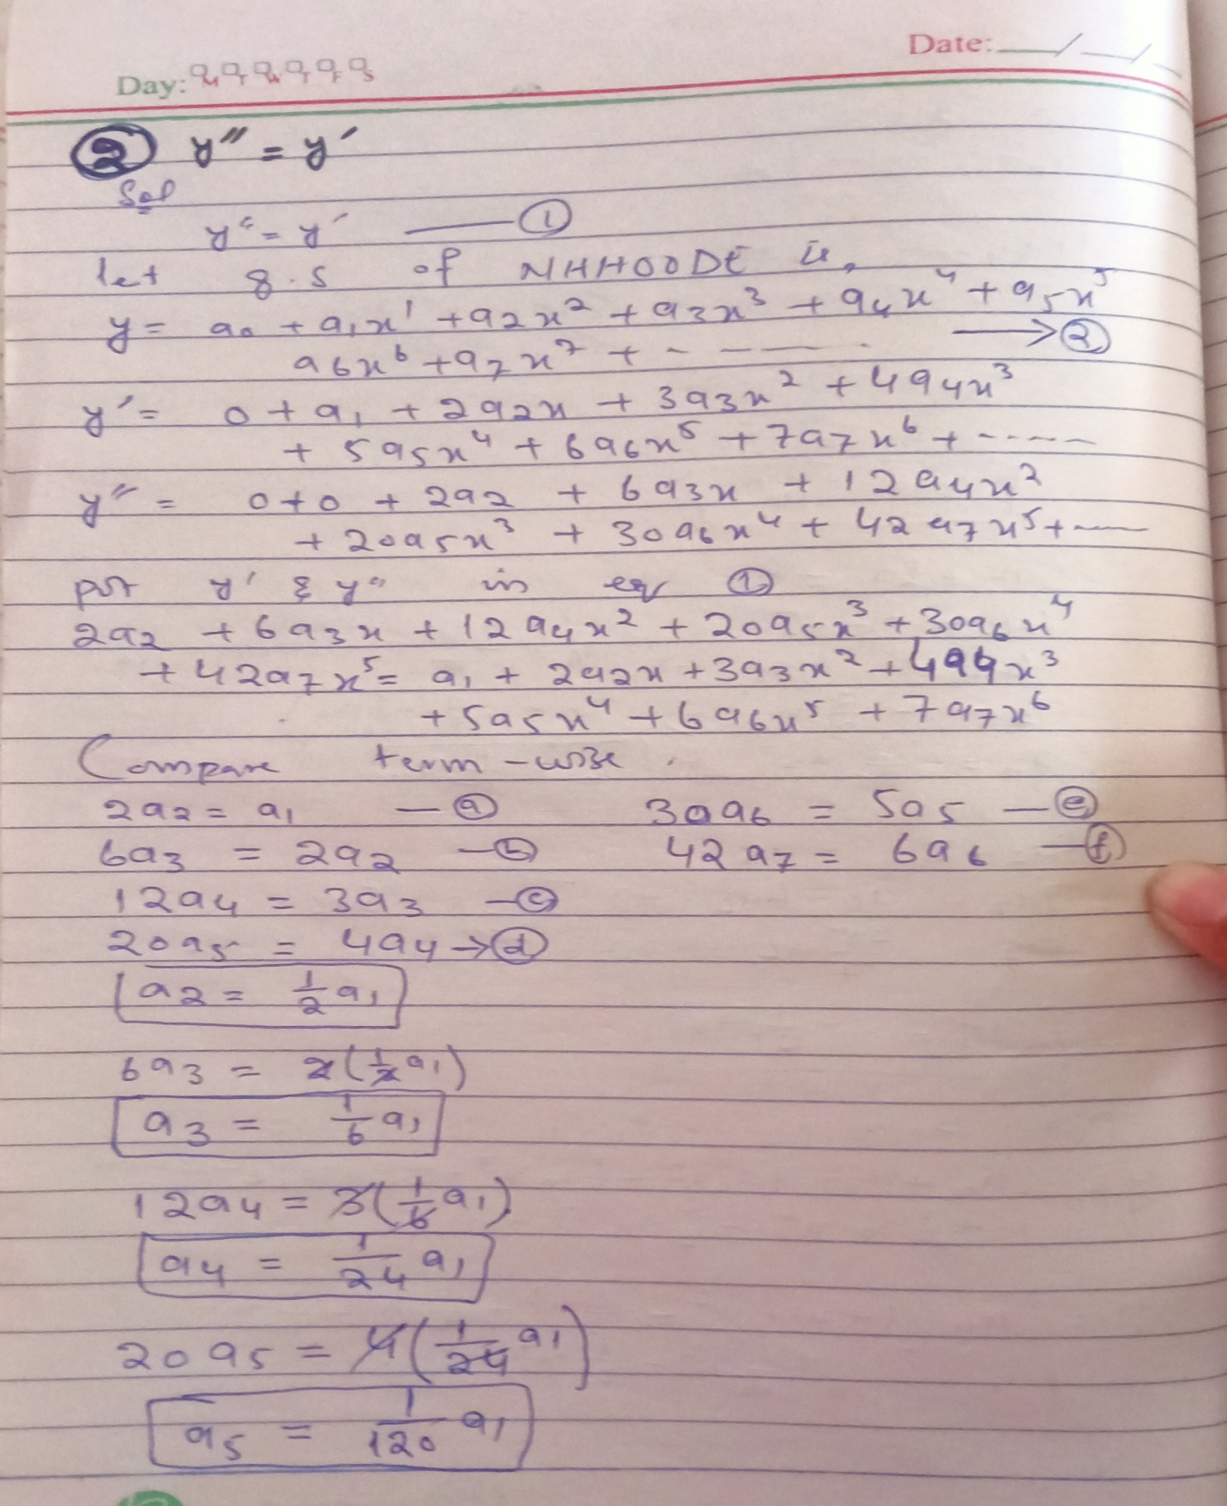

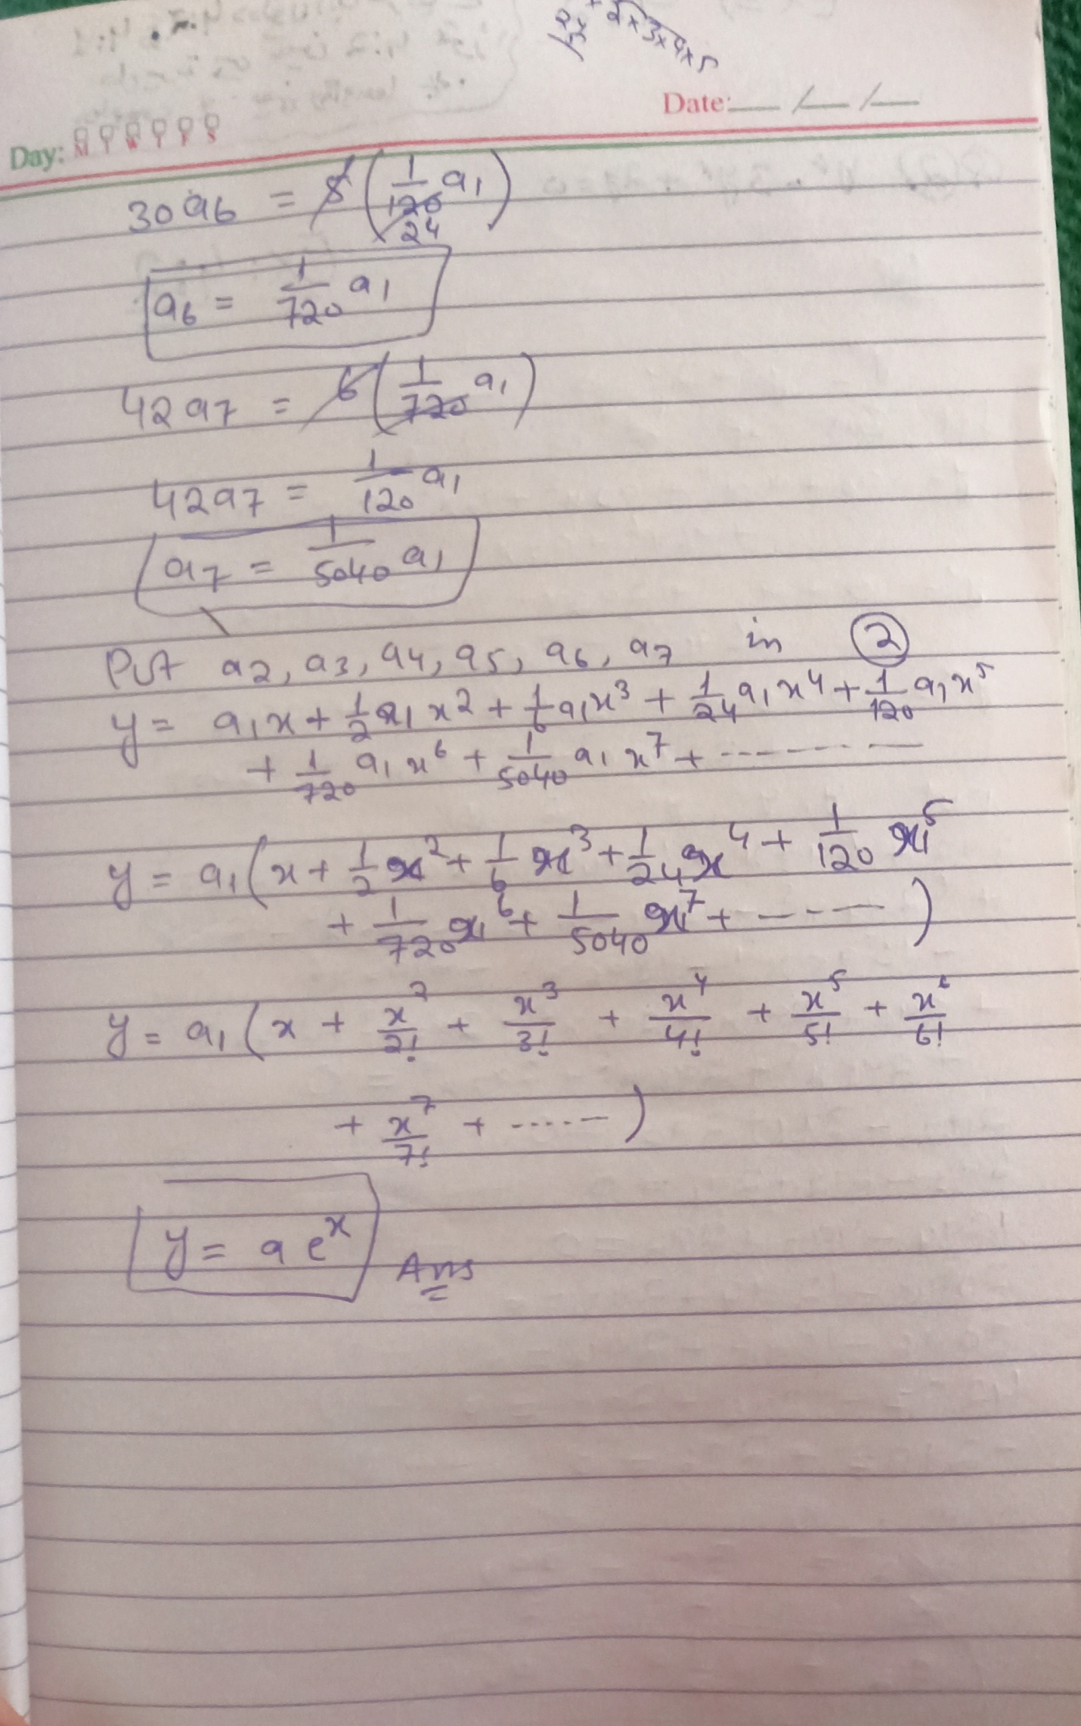

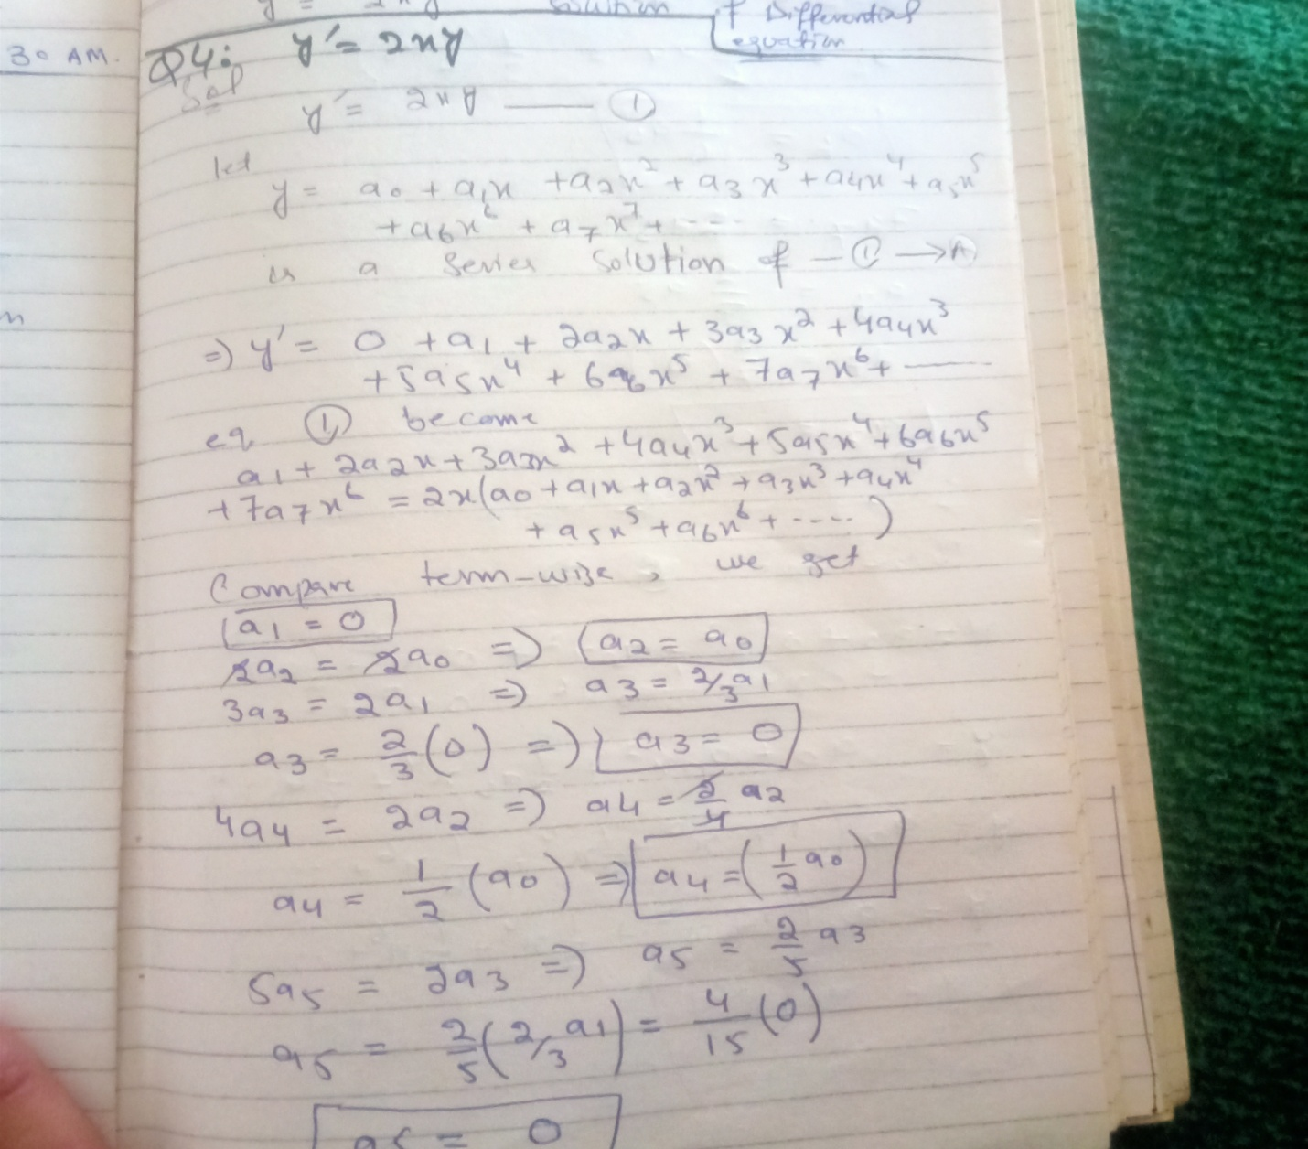

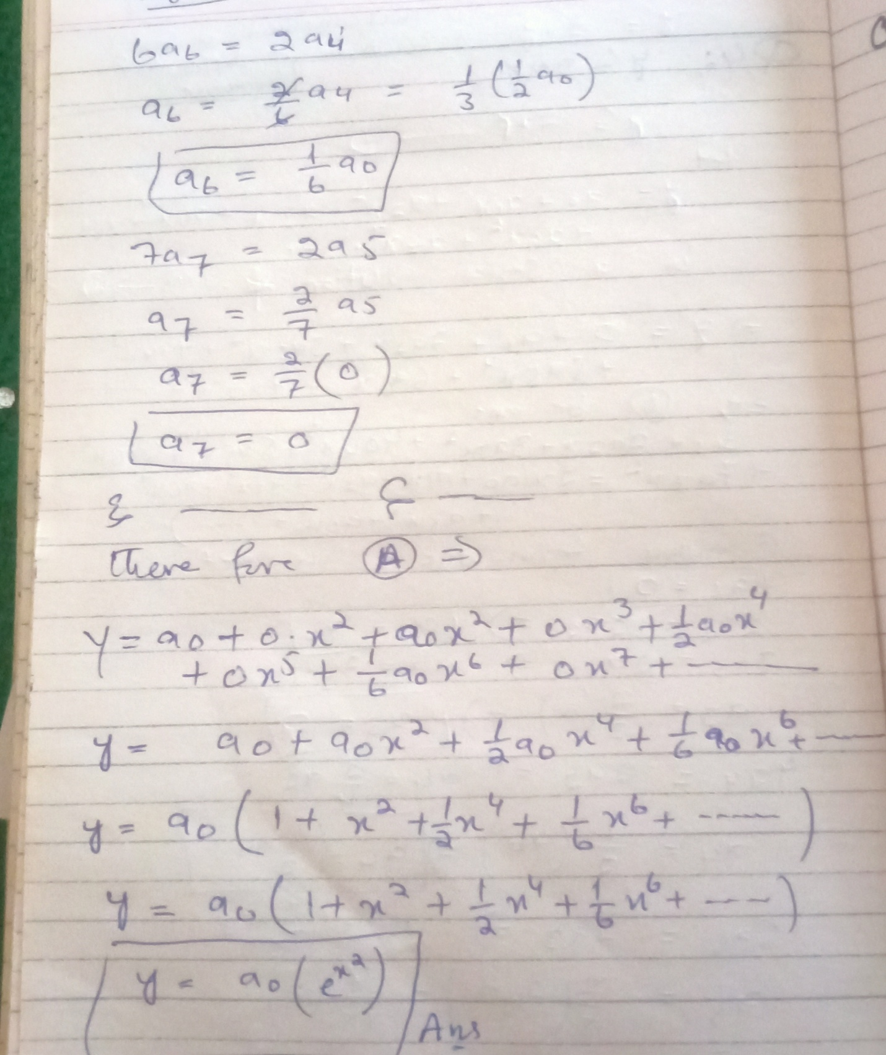





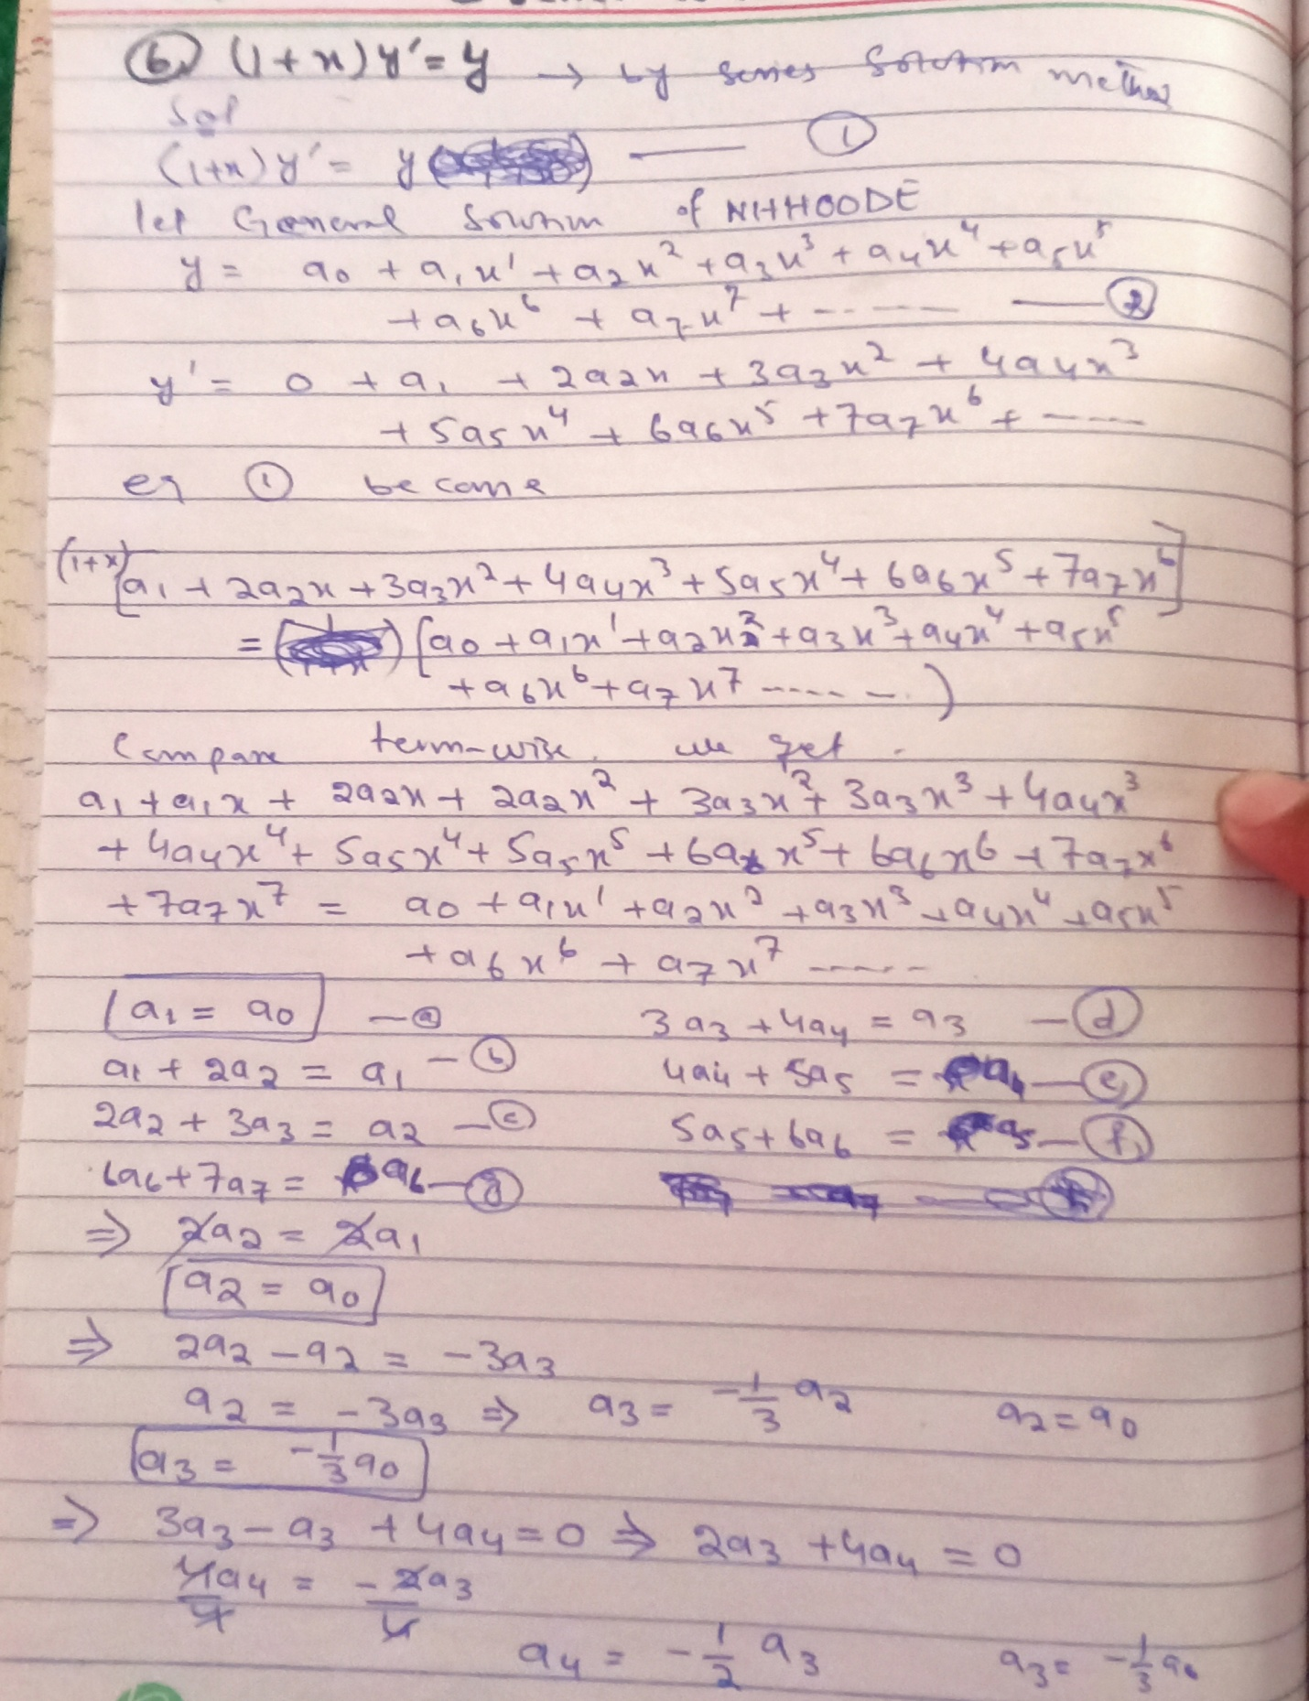

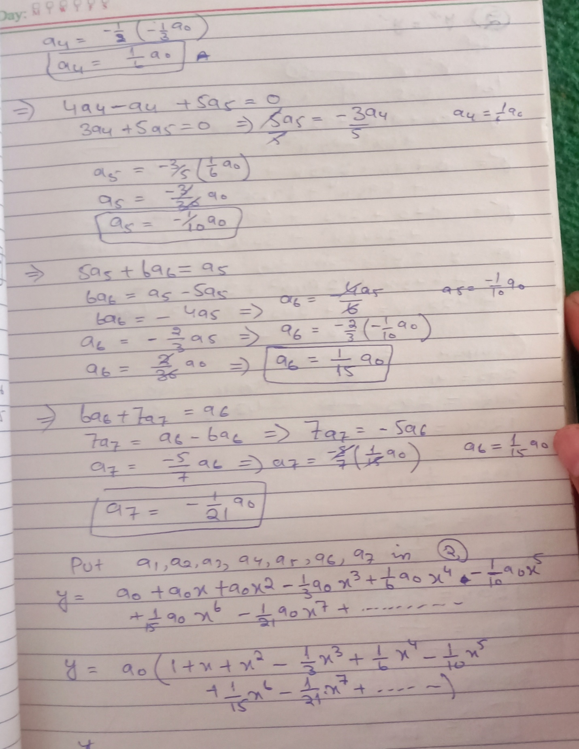

**Exercise 4:2 (2, 6, 8)**

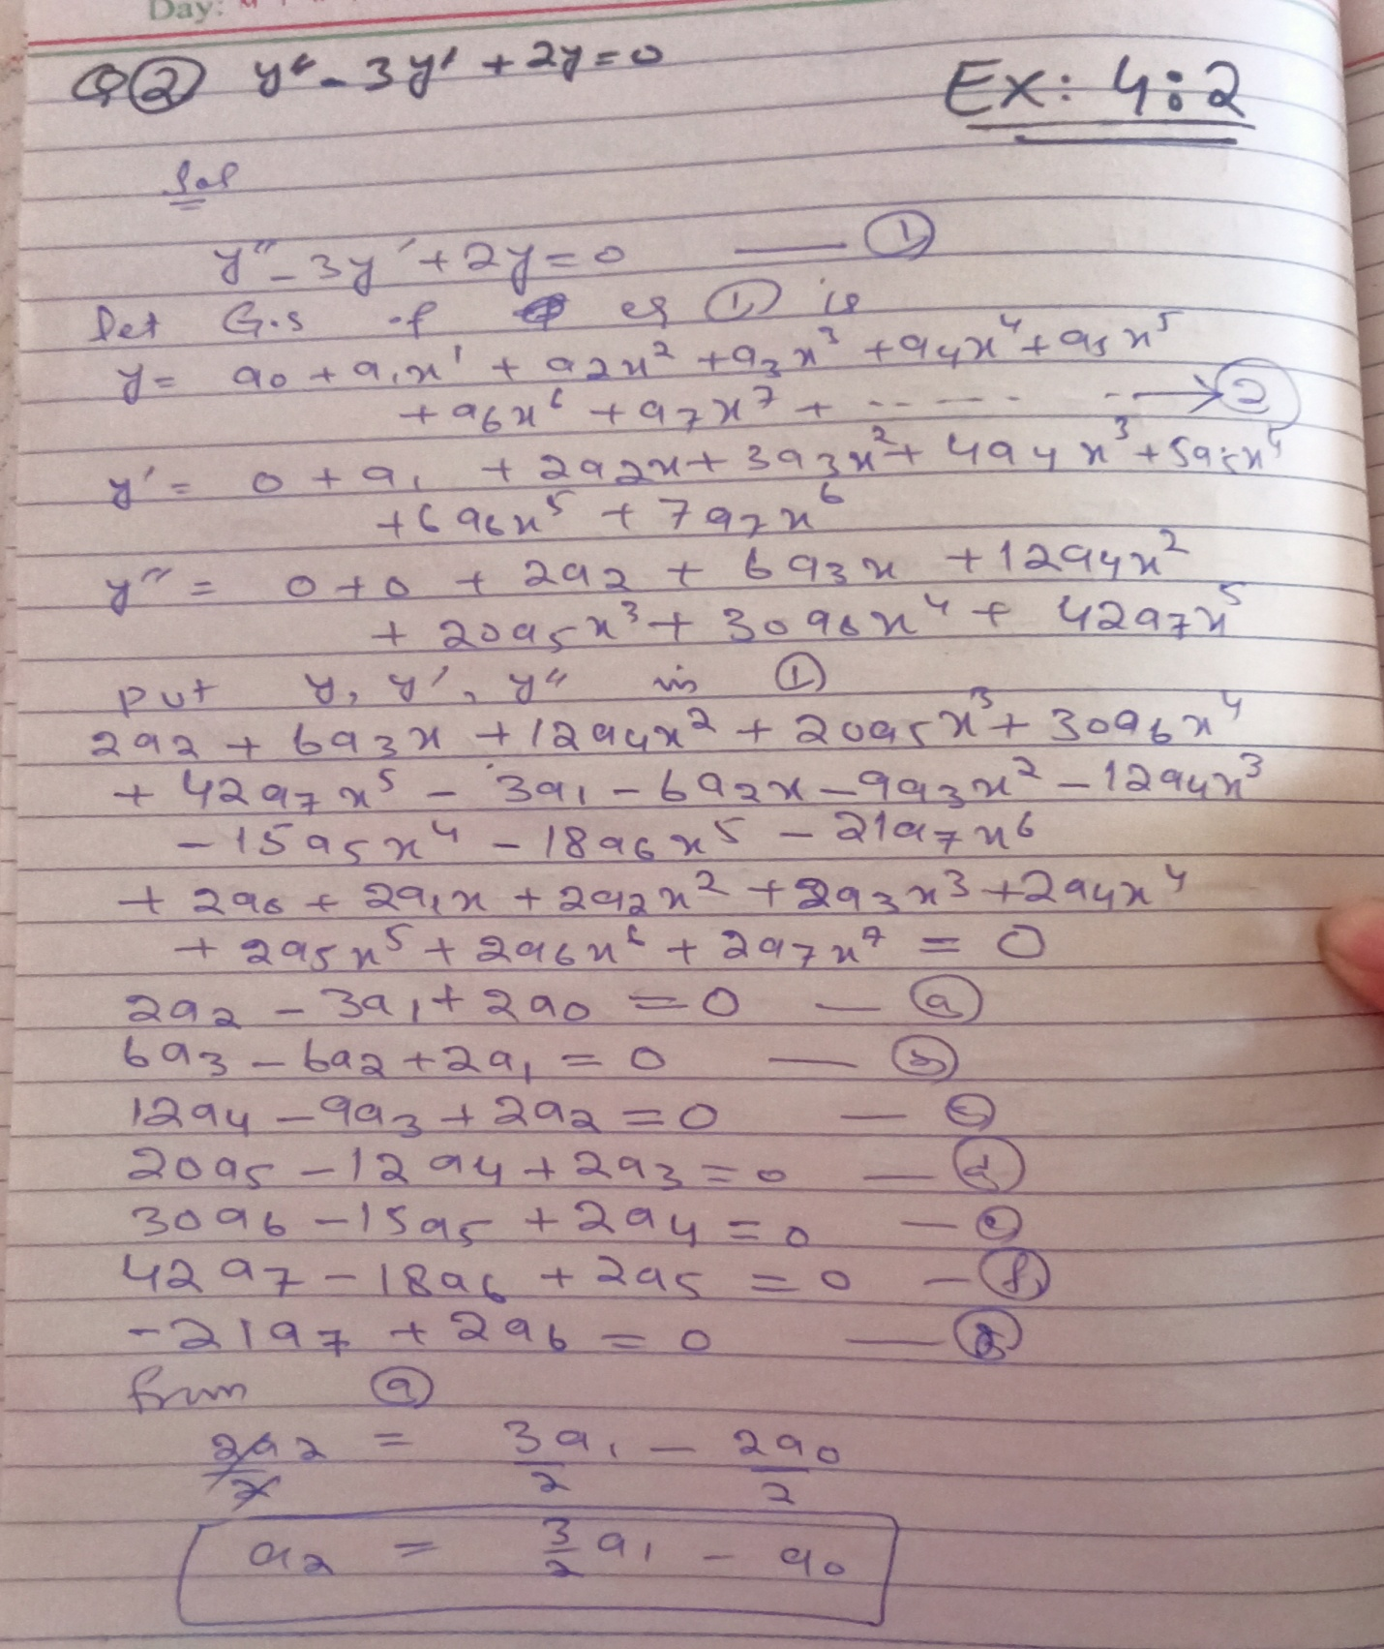

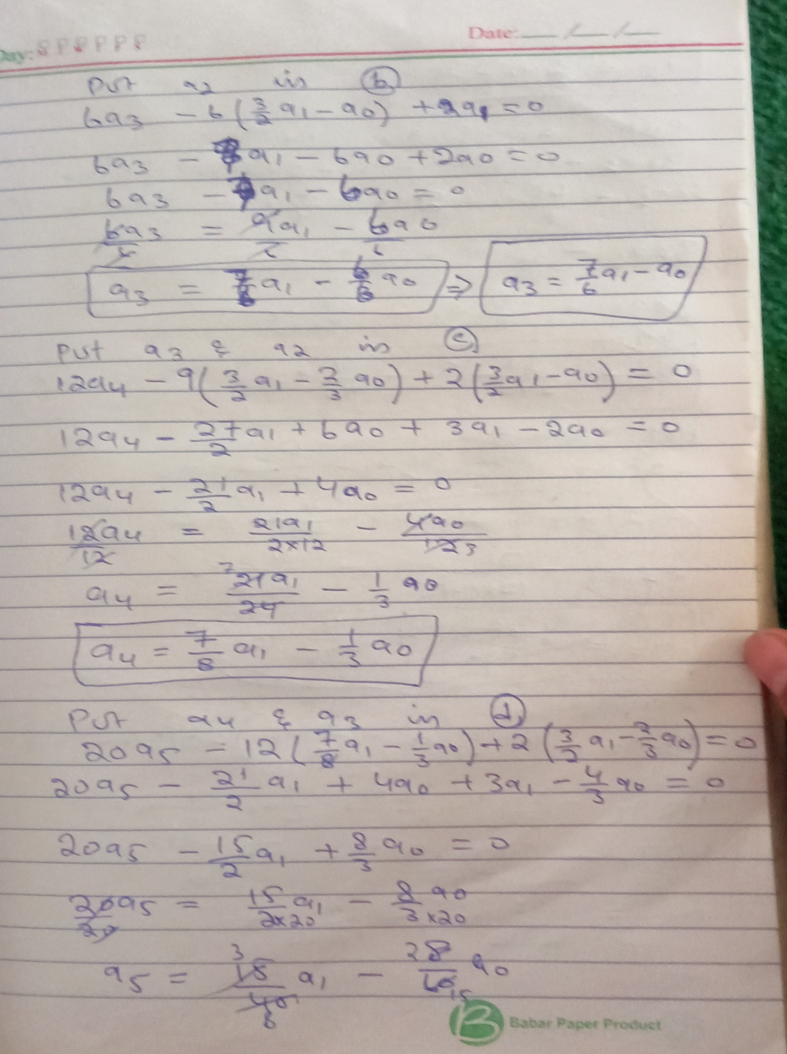

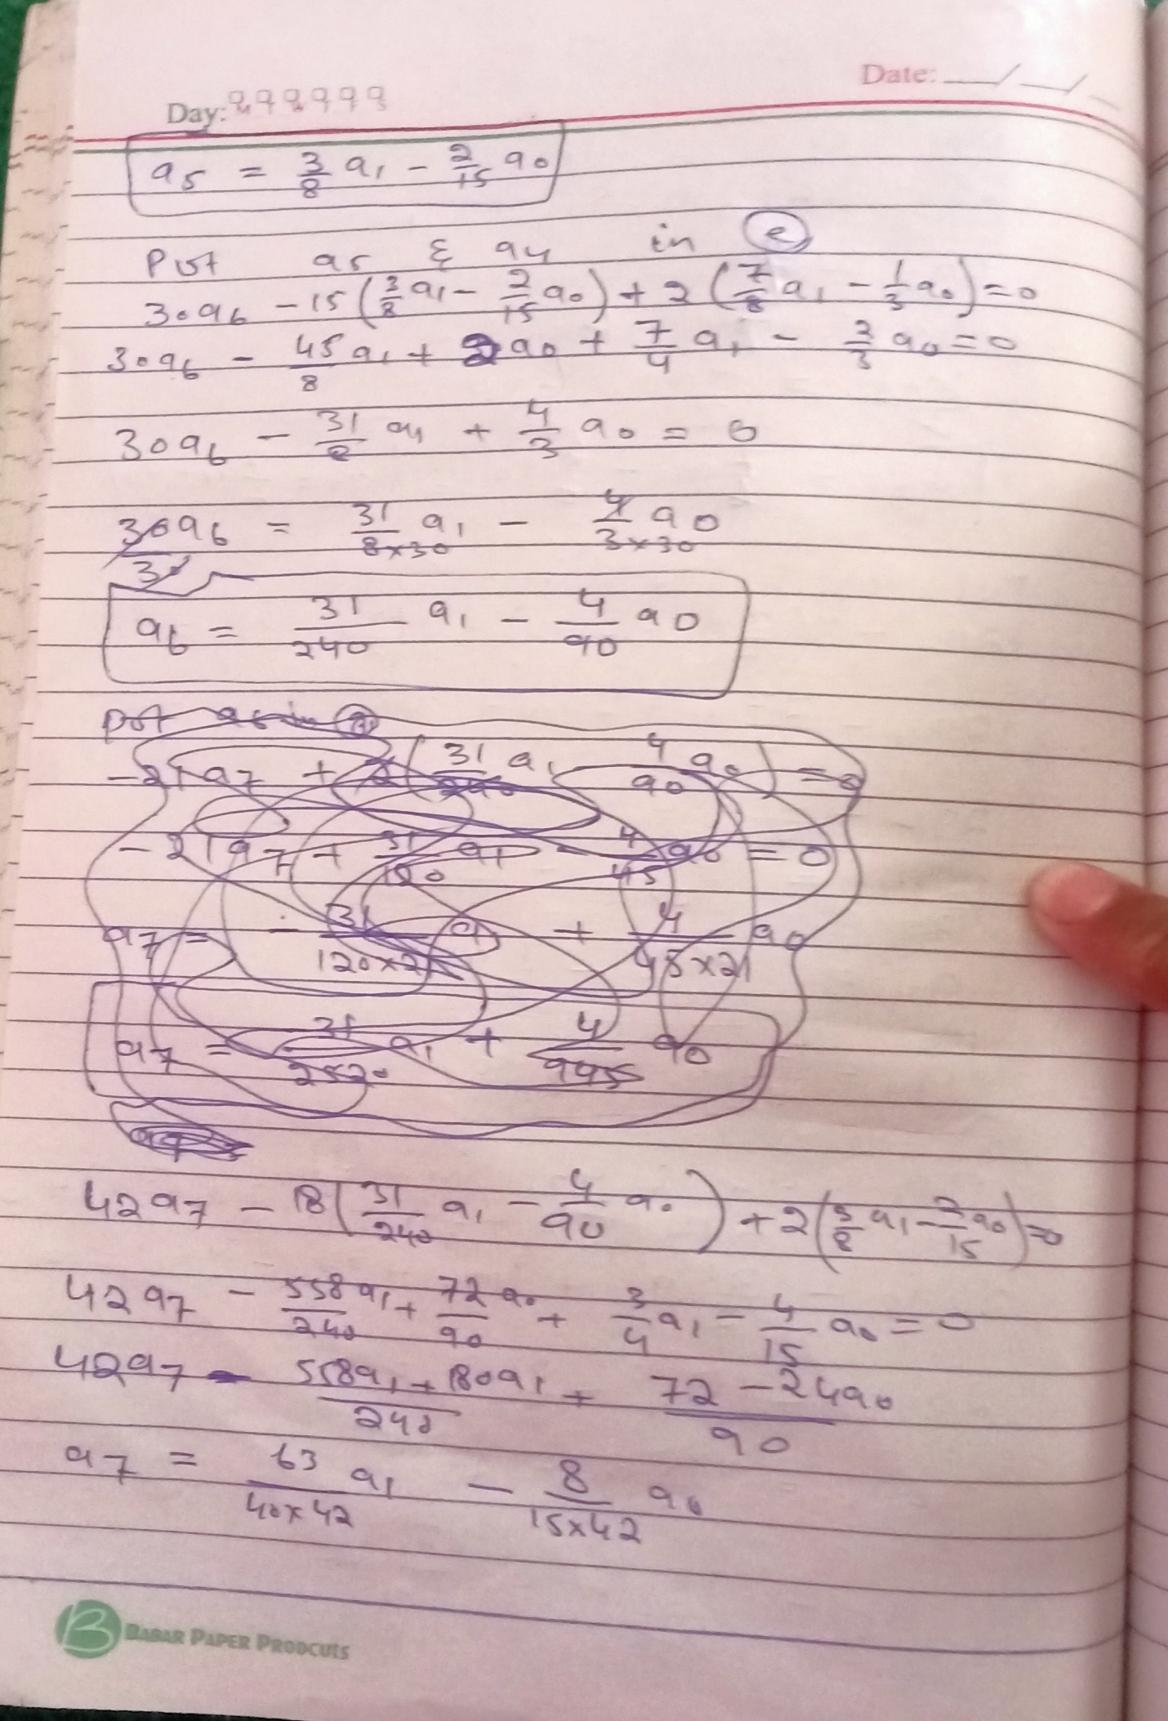

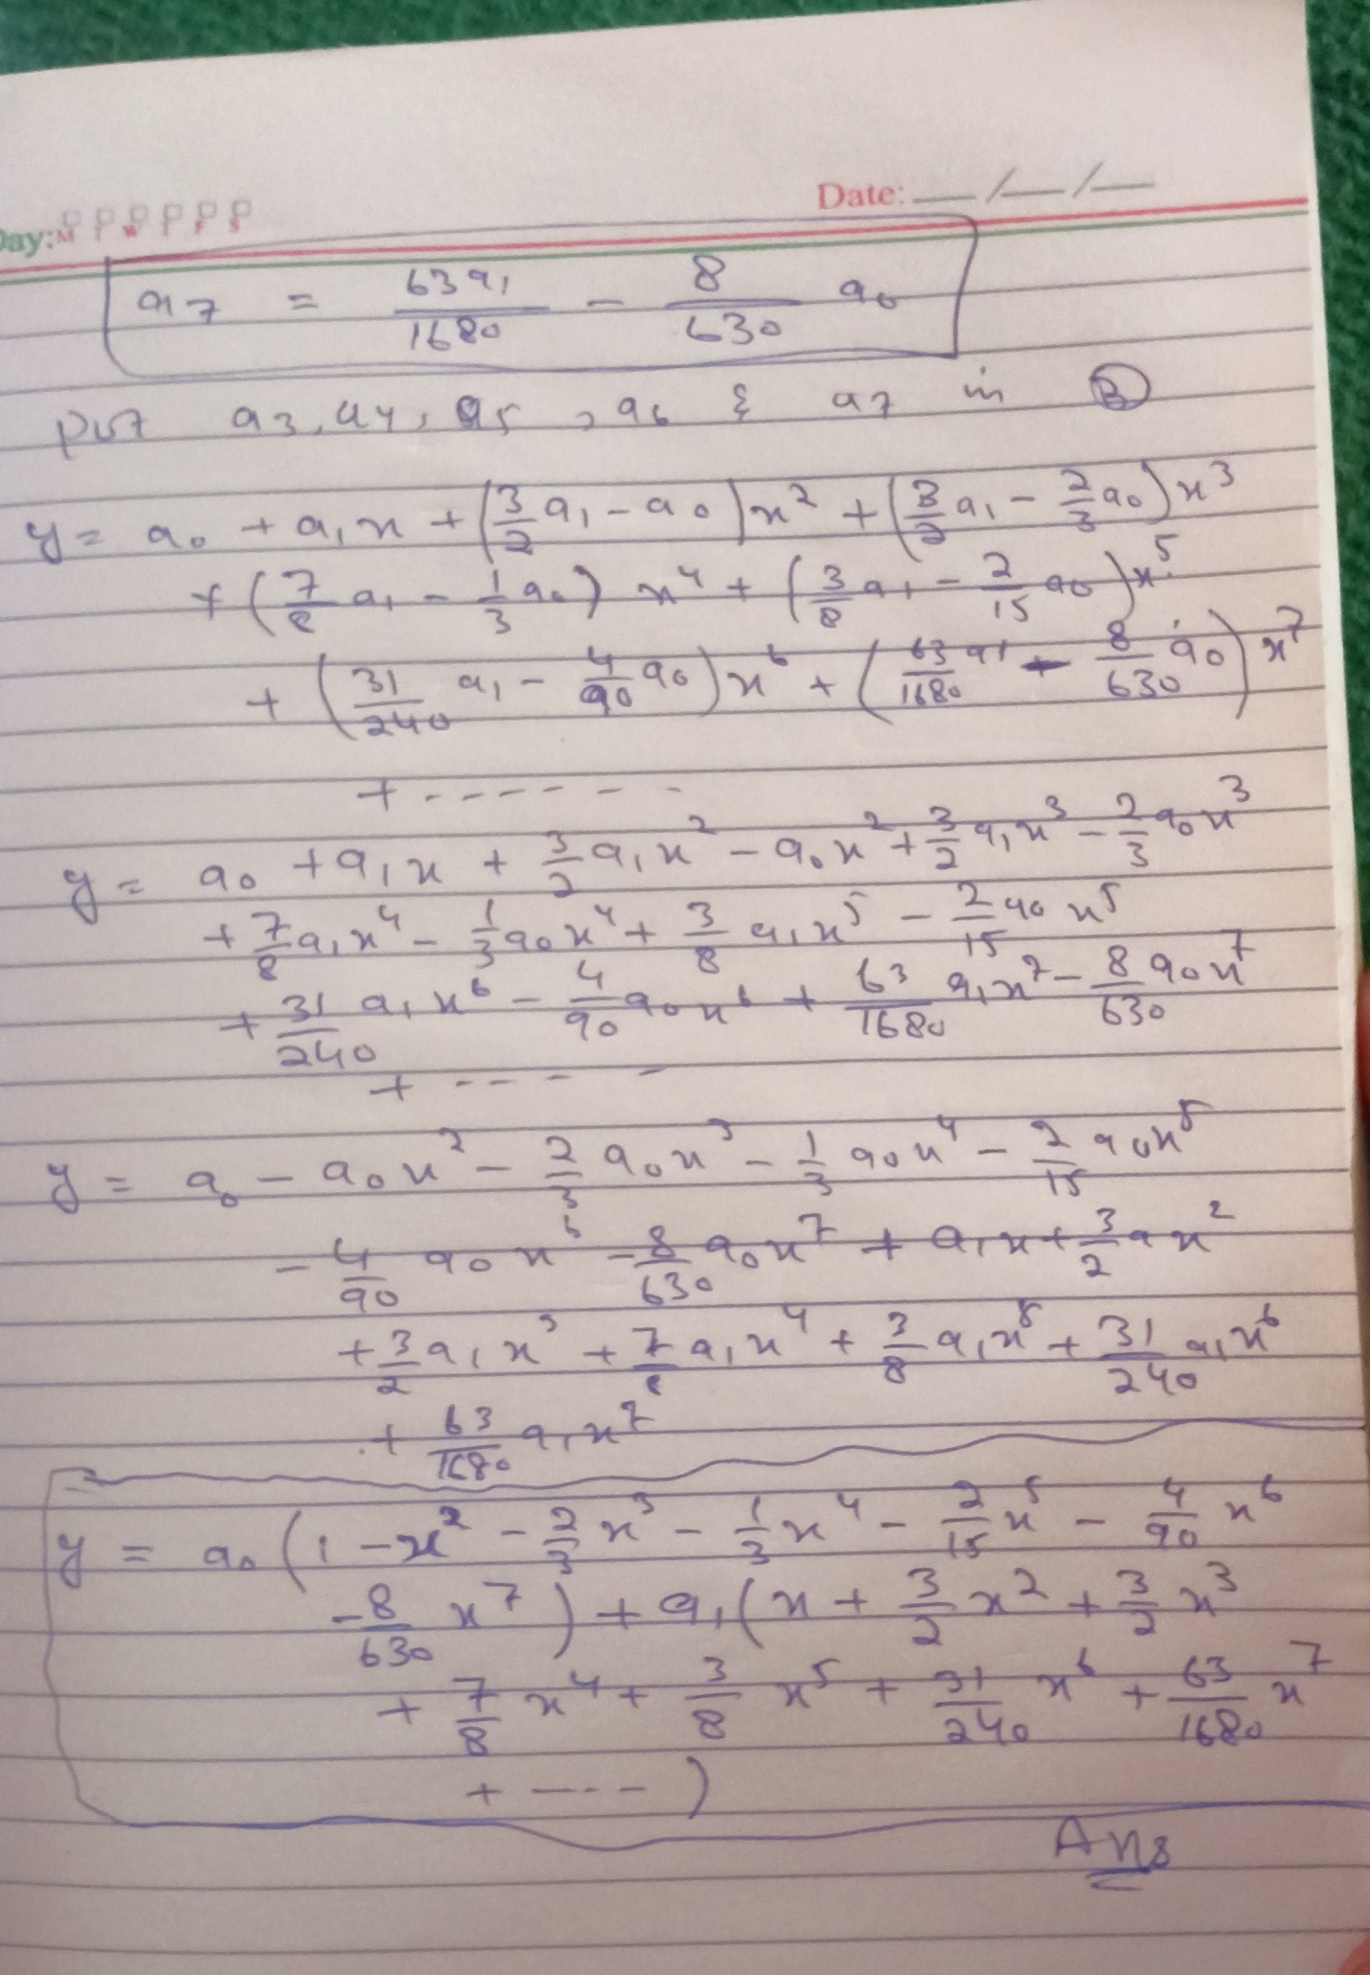

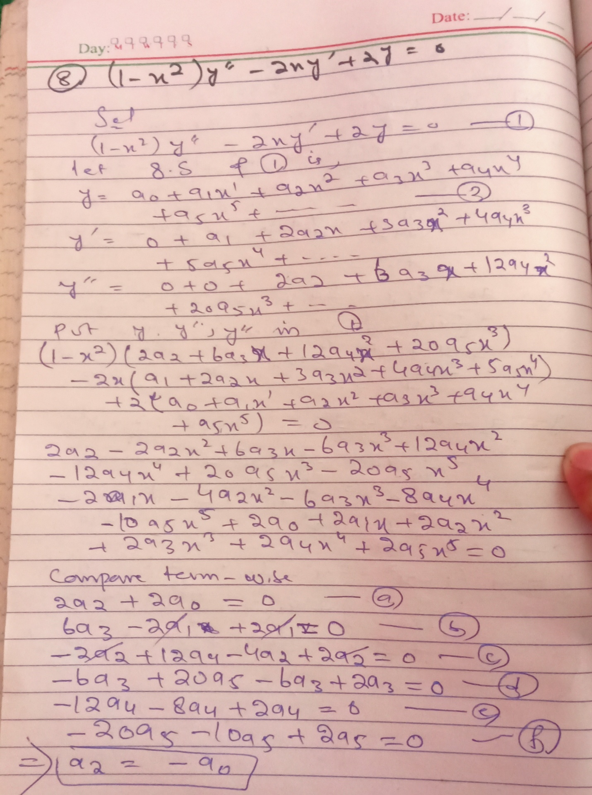

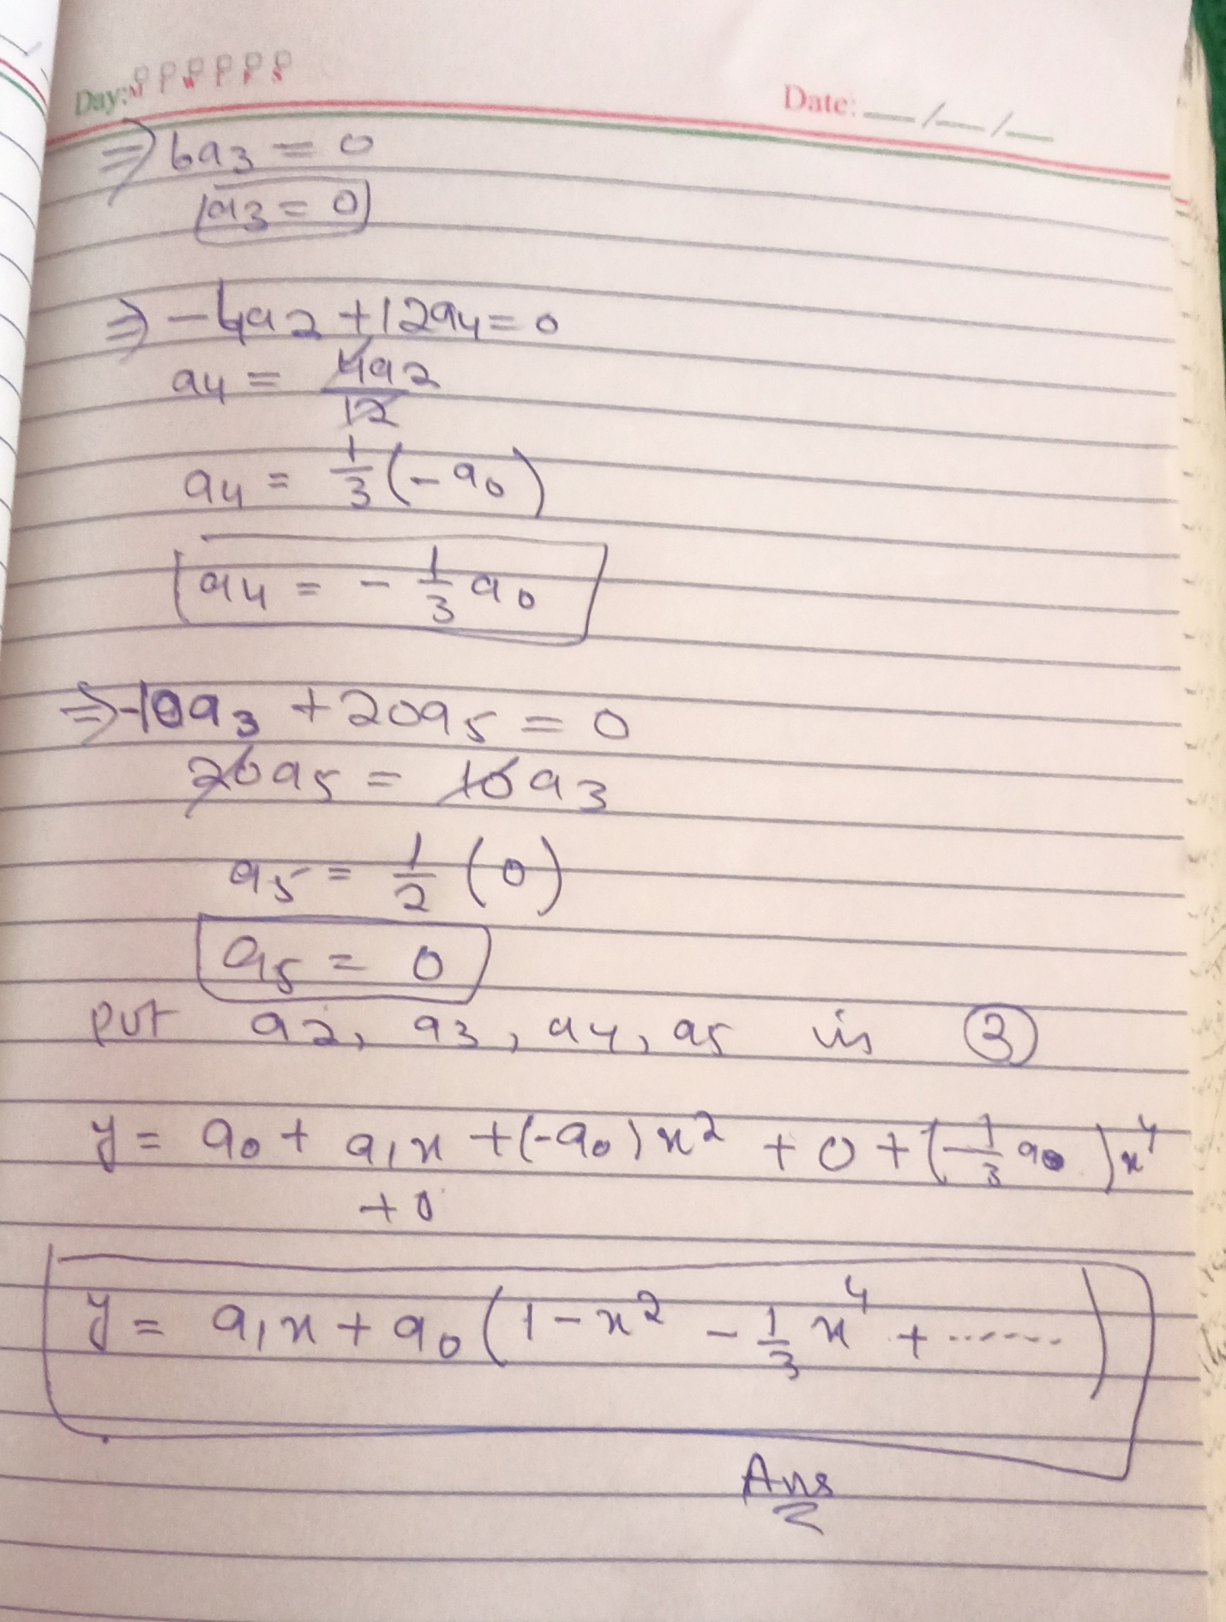

THE END